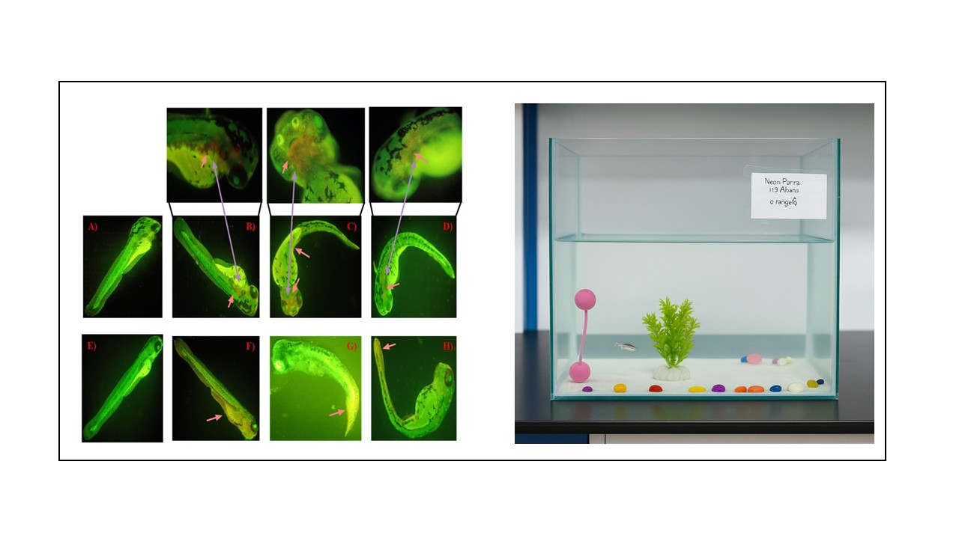
RPCP Centre for Zebrafish Toxicity Studies

Zebrafish have emerged as a robust and scientifically validated alternative to traditional rodent models in toxicity research. Their high sensitivity to chemical, environmental (including pesticide), and nanoparticle-induced toxicities enables early and reliable detection of adverse effects, thereby substantially reducing study timelines. With approximately 75% genetic homology to humans, zebrafish provide strong translational relevance for predicting human toxicity outcomes. Their rapid embryonic development, external fertilization, and transparent embryos further allow real-time visualization of organogenesis and precise identification of developmental or physiological abnormalities.

At Ramanbhai Patel College of Pharmacy, extensive expertise has been established in conducting diverse toxicity assessments using zebrafish models. Key proficiencies include neurotoxicity, genotoxicity, developmental toxicity, cardiotoxicity, as well as molecular mechanism-focused studies involving apoptosis, oxidative stress, and related pathways. These capabilities position the institute as a leading centre for comprehensive, mechanism-driven toxicity evaluation leveraging advanced zebrafish research platforms.

